International collaboration in scientific research in «V1001»: an analysis of patterns and impact

Abstract The present study sought to examine the trend and impact of international collaboration in scientific research in «V1001» «V1593». Using the «V1009» data («V1010»-«V1011») we found that «V1345» of «V1001» scientific output (n =«V1285» publications) involved international collaborations, with the «V1368» and «V1369» researchers being the most frequent partners. The proportion of international collaborations has «V1364» slightly over time at the expense of a «V1575» rate of domestic collaborations. The rate of growth in «V1001» scientific output was «V1182» per annum, and the growth was associated with «V1576» rather than purely «V1577». Moreover, internationally coauthored publications received «V1007» citation than domestic publications. Of note, publications with overseas first author had «V1573» citation rate than publications with domestic first author. These data suggest that the vast majority of scientific publications from «V1001» was attributable to «V1576», and this had a positive impact on the quality and visibility of «V1001» science.

Introduction
Advances in science and technology are major contributors to economic growth. The case of South Korea offers a great exemplar of the role of science and technology in economic development. Within three decades, South Korea has achieved economically what other Western countries have taken a century to realize. The achievement of South Korea, or the ''Korean Miracle'', are attributable to many factors, but science and technological innovation are among the most important contributors. In Australia alone, it has been estimated that advances in science had accounted for 20 to 30% growth in economic activities, employment, and exports. Although most scientific and technological advances are incremental and largely invisible to the public, the combined and cumulative progress resulting from these advances have had perceptible impacts on the economy. Scientific research and technological innovation can play a major role in allowing developing country to achieve economies comparable to those observed in developed countries.
Scientific research produces new information and knowledge that can promote technological innovation which, in turn, produce quality goods and services. Thus, scientific research can be considered a driving force for positive evolution in developing countries. One indicator of scientific research is the number of publications in peer-reviewed journals. "a robust and positive correlation between the number of peer-reviewed scientific publications and the knowledge economy had demonstrated in a previous study (Nguyen and Pham 2011).
Across the world, international collaboration in scientific research has increased rapidly in recent decades. Between 1986 and 1999, the proportion of internationally co-authored publications has increased by two-fold (Archi- bugi and Coco 2004), and in some countries, this proportion has risen to 40% (Schmoch and Schubert 2008) or 50% (9). In fact, collaboration in research is now the norm rather than exception, and this is also true for developing countries. For instance, in China, approximately half of all papers in healthcare science have been resulted from international collaborations (Chen et al. 2016). In Malaysia, approximately 40% of medical research papers published between 2001 and 2010 had an international collaboration component (Low et al. 2014). An interesting finding of this study is that there was a linear correlation between the proportion of international collaboration and the journal impact factor (Low et al. 2014), suggesting that papers involving an international collaboration are of higher quality than those without such collaborations. In developing countries, due to lack of expertise and poor infrastructure, international collaboration in scientific research is also regarded as an effective way to build scientific capacity and share resources (Wagner et al. 2001).
«V1001» is a «V1580» country that can be a good case study of the benefit of international scientific collaborations. The country has a long tradition of higher education and science. Governments have advanced that education and science were essential for achieving visions of a better future for «V1001». «V1001» has been open since «V1582». In parallel with its economic growth, the government has gradually increased budget for science and technology (S&T).
Over the past two decades, scientific research activities have also increased substantially as reflected by the number of peer reviewed publications (Nguyen and Pham 2011; Manh 2015). However, it is not clear how much of the growth in scientific activities was driven by international collaboration, and whether the rate of collaborations has changed over time. We hypothesize that the growth in scientific research in «V1001» during the past two decades has been driven by «V1576», and that «V1576» results in higher quality research that produces a greater impact as compared to pure «V1577» research.
The goal of this study was to test the hypotheses by identifying patterns of collaborations (domestic and international) in «V1001» scientific research by using co-authorship as a marker. We pursued three specific aims as follows: (1) to define the structure of scientific output from «V1001»; (2) to determine the level of domestic and international collaborations in «V1001» science; and (3) to determine the impact and quality of publications involving international collaborations publications vs purely domestic publications.

Data and methods
Data
The data used in this study were extracted from «V1009» database. The «V1009» is a heterogeneous graph containing scientific publication records, citation relationships between those publications, as well as authors, institutions, journals, conferences, and fields of study. The «V1009» databases encompass more than «V1004» publications, covering all fields of scientific research. We chose the «V1009» database because its large coverage scope. The «V1009» is also used by used by government agencies as a tool for in-depth analyses of scientific and technological trends and the development of statistical indicators on science, technology and innovation (STI).
We downloaded the entire set of publications published in «V1009» that include any of the «V1001» affiliations in their affiliations during the period of «V1010» and «V1011». The criteria of inclusion were publications published in English language. We included conferences, books, journals, and patents. The resulting dataset included, among others, the following variables: list of authors, affiliation, area of research, and the number of citations up to «V1011». Each publication included a list of institutional affiliation or affiliations of each author. For each publication and each author, we extracted the country or countries of affiliation "Based on the information, we classified an article into one of the following three groups: (a) single authored publications; (b) national collaboration, if the publication had more than one authors' affiliations and all affiliations were based in «V1001»; and (c) international collaboration, if the publication had at least one author whose affiliation was overseas.
Based on the research area classification, we grouped the articles into «V1012» broad groups «V1013», «V1014», «V1015», «V1016», «V1017», «V1018», «V1019», «V1020», «V1021», «V1022», «V1023», «V1024», «V1025», «V1026», «V1027», «V1028», «V1029», «V1030», and «V1031». It should be noted that some publications were classified into more than two research areas, therefore the sum of individual research areas did not necessarily add up to the totality of publications.

Data analysis
We used mostly descriptive statistical methods to analyze the data. For trend comparison purpose, we divided the study period into «V1032» 5-year subperiods: “ «V1033»; «V1034»; «V1035» and «V1036»". The rate of growth was estimated by Computer Annual Growth Rate (CAGR), (ending Year)/(beginning year)^{(1/(n-1)} -1. In this formulation, n is the number of Years in the data set.
In addition, we quantify the degree of collaboration for each research area by the collaboration coefficient (CC). The CC was determined as follows: let P_{j} be the number of publications with j authors, N be the number of publications, and A the maximum number of authors in a research area, the coefficient is defined as: CC = 1 − (∑^{A} _{j=1} (1/j)P_{j} /N). This coefficient ranges between 0 (for no collaboration, single author publications dominate) to 1 (for total collaboration).
We didn't consider quality and impact factors because they vary from time to time. For the analysis of citation, we further classified an article according to first authorship status: (1) Dom: if the article has no international collaboration; (2) IC.IA: if the article was internationally authored, and the article's first author has an overseas affiliation; and (3) IC.SA if the article was internationally authored, and the article's first author was based in «V1001».
Based on the country of affiliation, we used a network analysis method to construct a network graph of research collaborations between countries in the world, with «V1001» being at the center. In this method, the weight of connection between any two countries was defined by the number of publications. All analyses were conducted using «V1005» and «V1006» on the Window platform.

Results

Trends of scientific output
Between «V1010»- «V1011», «V1001» published «V1002» publications in «V1009». However, after excluding «V1038» publications that had incomplete information, «V1285» publications were available for further analysis. Analysis by broad research area showed that almost «V1040» of the publication output was concentrated on just 5 areas: «V1013» («V1061» of total output), followed by «V1014» («V1062»), «V1015» («V1063»), «V1016» («V1064»), and «V1017» («V1065»). Research in «V1018», «V1019», «V1020», «V1021», «V1022», «V1023», «V1024», «V1025» ,«V1026», «V1027», «V1028», «V1029», «V1030» and «V1031» each accounted for less than «V1065» of total scientific output (Fig. 1).
The number of articles has grown continuously, with the average rate of increase being «V1182» per annum. In «V1011», «V1001» published «V1081» publications, and this output increase from «V1080» publications in «V1010». However, there appeared to be two phases of growth. "Between «V1010» and «V1041», the rate of growth was approximately «V1042» per annum, and this rate was increased to «V1182» between «V1010» and «V1011». The research areas that recorded the strongest growth (more than 20% per year) were «V1601», «V1602», «V1603», «V1604», «V1605», «V1606», «V1607», «V1608» and «V1609» (Table 1).
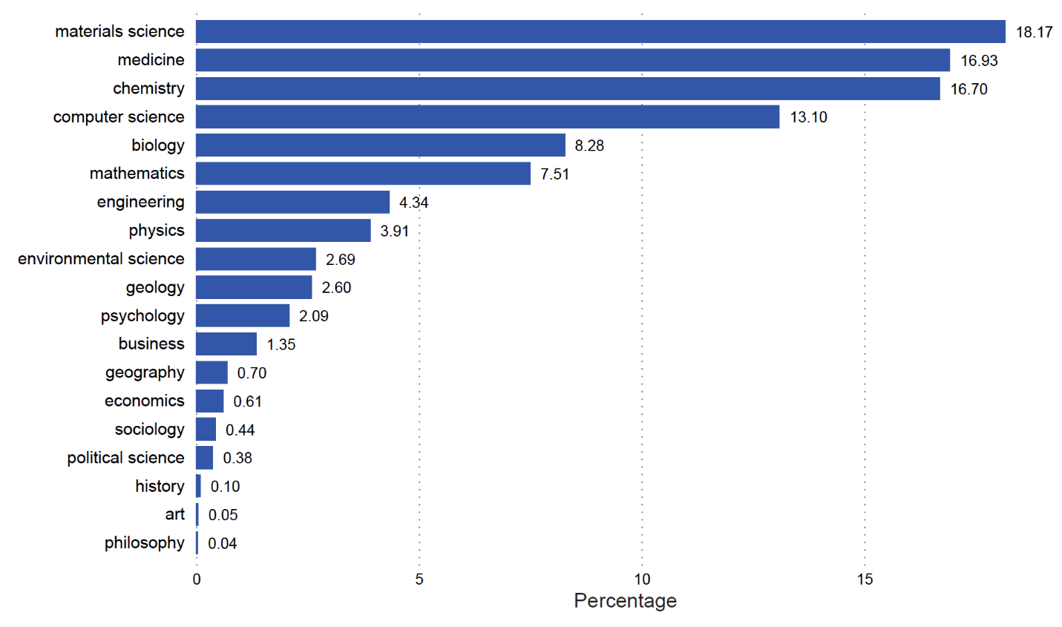
Fig. 1 Composition of scientific research output from «V1001» as reflected by the proportion of scientific publication stratified by broad research area («V1010»–«V1011»)

Table 1 Number of original articles from «V1001» published in «V1009» during the period of «V1010»-«V1011»
Broad area of research | «V1033» | «V1034» | «V1035» | «V1036» | Rate of growth (%/year)
«V1013» | «V1083» | «V1103» | «V1123» | «V1143» | «V1163»
«V1014» | «V1084» | «V1104» | «V1124» | «V1144» | «V1164»
«V1015» | «V1085» | «V1105» | «V1125» | «V1145» | «V1165»
«V1016» | «V1086» | «V1106» | «V1126» | «V1146» | «V1166»
«V1017» | «V1087» | «V1107» | «V1127»«V1127» | «V1147» | «V1167»
«V1018» | «V1088» | «V1108» | «V1128» | «V1148» | «V1168»
«V1019» | «V1089» | «V1109» | «V1129» | «V1149» | «V1169»
«V1020» | «V1090» | «V1110» | «V1130» | «V1150» | «V1170»
«V1021» | «V1091» | «V1111» | «V1131» | «V1151» | «V1171»
«V1022» | «V1092» | «V1112» | «V1132» | «V1152» | «V1172»
«V1023» | «V1093» | «V1113» | «V1133» | «V1153» | «V1173»
«V1024» | «V1094» | «V1114» | «V1134» | «V1154» | «V1174»
«V1025» | «V1095» | «V1115» | «V1135» | «V1155» | «V1175»
«V1026» | «V1096» | «V1116» | «V1136» | «V1156» | «V1176»
«V1027» | «V1097» | «V1117» | «V1137» | «V1157» | «V1177»
«V1028» | «V1098» | «V1118» | «V1138» | «V1158» | «V1178»
«V1029» | «V1099» | «V1119» | «V1139» | «V1159» | «V1179»
«V1030» | «V1100» | «V1120» | «V1140» | «V1160» | «V1180»
«V1031» | «V1101» | «V1121» | «V1141» | «V1161» | «V1181»
All areas | «V1102» | «V1122» | «V1142» | «V1162» | «V1182»

Research collaborations
Most publications had multiple authors. Based on the number of authors, we computed the coefficient of collaboration, and results are shown in Table 2. The coefficient of collaboration increased during the study period for virtually all broad research areas.
Broad area of research | «V1033» | «V1034» | «V1035» | «V1036»
«V1013» | «V1187» | «V1207» | «V1227» | «V1247»
«V1014» | «V1188» | «V1208» | «V1228» | «V1248»
«V1015» | «V1189» | «V1209» | «V1229» | «V1249»
«V1016» | «V1190» | «V1210» | «V1230» | «V1250»
«V1017» | «V1191» | «V1211» | «V1231» | «V1251»
«V1018» | «V1192» | «V1212» | «V1232» | «V1252»
«V1019» | «V1193» | «V1213» | «V1233» | «V1253»
«V1020» | «V1194» | «V1214» | «V1234» | «V1254»
«V1021» | «V1195» | «V1215» | «V1235» | «V1255»
«V1022» | «V1196» | «V1216» | «V1236» | «V1256»
«V1023» | «V1197» | «V1217» | «V1237» | «V1257»
«V1024» | «V1198» | «V1218» | «V1238» | «V1258»
«V1025» | «V1199» | «V1219» | «V1239» | «V1259»
«V1026» | «V1200» | «V1220» | «V1240» | «V1260»
«V1027» | «V1201» | «V1221» | «V1241» | «V1261»
«V1028» | «V1202» | «V1222» | «V1242» | «V1262»
«V1029» | «V1203» | «V1223» | «V1243» | «V1263»
«V1030» | «V1204» | «V1224» | «V1244» | «V1264»
«V1031» | «V1205» | «V1225» | «V1245» | «V1265»
All areas | «V1206» | «V1226» | «V1246» | «V1572»
Table 2 Coefficient of collaboration between «V1010» and «V1011» for broad research areas

Table 3 presents the extent of domestic and international collaborations based on co-authorship in scientific publications. Overall, approximately «V1305» of publications published between «V1010» and «V1011» were single authored. However, the proportion of single authored publications varied between research areas, with «V1186» publications having the highest proportion («V1346»), followed by «V1347» («V1348»), and «V1349» («V1350»). «V1351», «V1352» and «V1353», had a lower proportion of single authored publications.
Table 3 «V1001» scientific output classified by collaborative status and research area
Broad area of research | Number of publications | Single authored  publications (%) | Collaboration  (domestic; %) | Collaboration  (international; %)
«V1013» | «V1266» | «V1286» | «V1306» | «V1326»
«V1014» | «V1267» | «V1287» | «V1307» | «V1327»
«V1015» | «V1268» | «V1288» | «V1308» | «V1328»
«V1016» | «V1269» | «V1289» | «V1309» | «V1329»
«V1017» | «V1270» | «V1290» | «V1310» | «V1330»
«V1018» | «V1271» | «V1291» | «V1311» | «V1331»
«V1019» | «V1272» | «V1292» | «V1312» | «V1332»
«V1020» | «V1273» | «V1293» | «V1313» | «V1333»
«V1021» | «V1274» | «V1294» | «V1314» | «V1334»
«V1022» | «V1275» | «V1295» | «V1315» | «V1335»
«V1023» | «V1276» | «V1296» | «V1316» | «V1336»
«V1024» | «V1277» | «V1297» | «V1317» | «V1337»
«V1025» | «V1278» | «V1298» | «V1318» | «V1338»
«V1026» | «V1279» | «V1299» | «V1319» | «V1339»
«V1027» | «V1280» | «V1300» | «V1320» | «V1340»
«V1028» | «V1281» | «V1301» | «V1321» | «V1341»
«V1029» | «V1282» | «V1302» | «V1322» | «V1342»
«V1030» | «V1283» | «V1303» | «V1323» | «V1343»
«V1031» | «V1284» | «V1304» | «V1324» | «V1344»
All areas | «V1285» | «V1305» | «V1325» | «V1345»
All singled authored papers had affiliation in «V1001»

Approximately «V1325» of published publications had multiple domestic authors (i.e., domestic collaboration), and «V1345» had at least one international affiliation (i.e., international collaboration). «V1887» had the highest proportion of collaboration. For instance, «V1888» of publications in «V1887» had at least one overseas affiliation. Between «V1033» and «V1036», the number of publications was increased by «V1362», and «V1363» of this increase was attributable to internationally coauthored publications.
There was an «V1364» in the proportion of international collaboration publications. During the period of «V1033», almost «V1365» of «V1001» scientific output had an international coauthor or coauthors, this proportion raise to «V1366» during the period of «V1036». The «V1364» was observed mainly in «V1590», and «V1591». Nevertheless, some research areas recorded a decrease in international collaboration: «V1892».

Countries of collaboration
Overall, «V1001» had collaborated with more than «V1367» countries around the world. The top 20 countries of collaboration are shown in Table 4. Among the top 20 countries, «V1619» were classified as scientifically advanced or developed countries. The «V1368» was the leading partner for «V1001», with each accounted for «V1488» of total scientific output from «V1001», and this proportion was followed by «V1369» («V1489»). Collaborations with «V1370», «V1371», and «V1372» also accounted for a considerable share of «V1001» scientific output. In fact, the top 10 countries accounted for almost «V1508» of the collaborative publications.
Table 4 Top 20 countries that have had scientific collaborations with «V1001» during the period of «V1010» - «V1011»
Country | «V1033» | «V1034» | «V1035» | «V1036» | Total («V1010»-«V1011») | Percent of total (%)
«V1368» | «V1388» | «V1408» | «V1428» | «V1448» | «V1468» | «V1488»
«V1369» | «V1389» | «V1409» | «V1429» | «V1449» | «V1469» | «V1489»
«V1370» | «V1390» | «V1410» | «V1430» | «V1450» | «V1470» | «V1490»
«V1371» | «V1391» | «V1411» | «V1431» | «V1451» | «V1471» | «V1491»
«V1372» | «V1392» | «V1412» | «V1432» | «V1452» | «V1472» | «V1492»
«V1373» | «V1393» | «V1413» | «V1433» | «V1453» | «V1473» | «V1493»
«V1374» | «V1394» | «V1414» | «V1434» | «V1454» | «V1474» | «V1494»
«V1375» | «V1395» | «V1415» | «V1435» | «V1455» | «V1475» | «V1495»
«V1376» | «V1396» | «V1416» | «V1436» | «V1456» | «V1476» | «V1496»
«V1377» | «V1397» | «V1417» | «V1437» | «V1457» | «V1477» | «V1497»
«V1378» | «V1398» | «V1418» | «V1438» | «V1458» | «V1478» | «V1498»
«V1379» | «V1399» | «V1419» | «V1439» | «V1459» | «V1479» | «V1499»
«V1380» | «V1400» | «V1420» | «V1440» | «V1460» | «V1480» | «V1500»
«V1381» | «V1401» | «V1421» | «V1441» | «V1461» | «V1481» | «V1501»
«V1382» | «V1402» | «V1422» | «V1442» | «V1462» | «V1482» | «V1502»
«V1383» | «V1403» | «V1423» | «V1443» | «V1463» | «V1483» | «V1503»
«V1384» | «V1404» | «V1424» | «V1444» | «V1464» | «V1484» | «V1504»
«V1385» | «V1405» | «V1425» | «V1445» | «V1465» | «V1485» | «V1505»
«V1386» | «V1406» | «V1426» | «V1446» | «V1466» | «V1486» | «V1506»
«V1387» | «V1407» | «V1427» | «V1447» | «V1467» | «V1487» | «V1507»

Figure 2 visualizes the inter-country collaborations. Overall, there were 35 countries that formed the network structure of international collaborations in «V1001» scientific output between «V1010» and «V1011». Evidently, the figure colored the mostly developed countries such as «V1889», «V1890», and «V1891» in green.
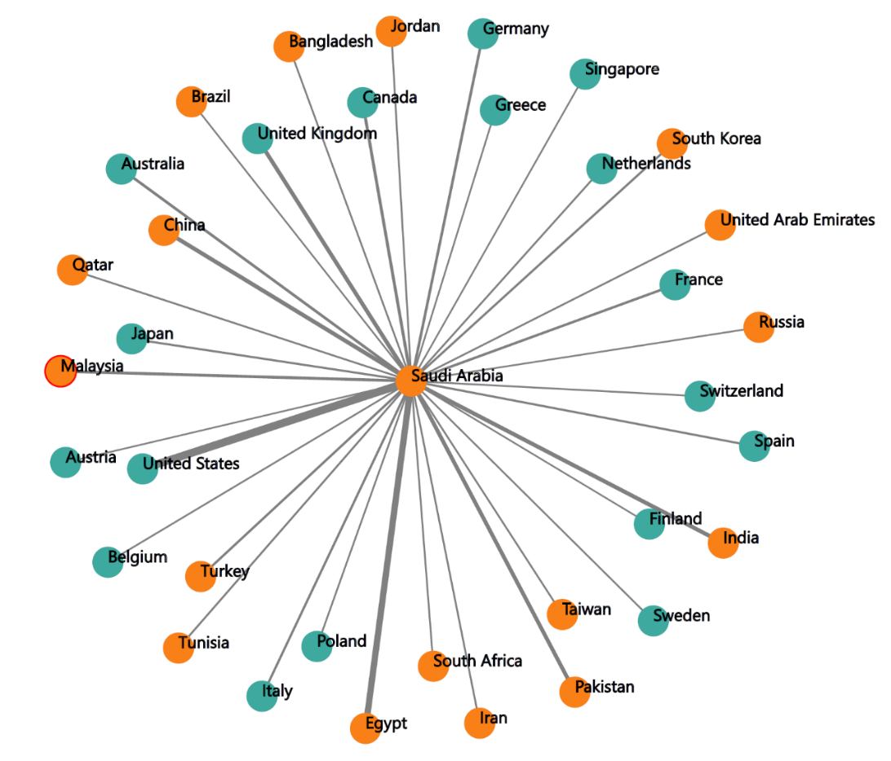

Fig. 2 Patterns of international collaborations in scientific research based on authors’ affiliations of publications that have been published in «V1009» during the period of «V1010» – «V1011». The thickness of connected line reflects the number of jointly coauthored publications.
International collaboration and impact
Using the criteria described in the Methods section, we grouped the articles into three groups: domestic authors (DOM), internationally collaborated publications with domestic first authors (IC.SA), and internationally collaborated publications with overseas first authors (IC.IA). Overall, approximately «V1893» of total publications were IC.IA, «V1894»were IC.SA, and the rest («V1325») were DOM.

Citation analysis
To assess the association between international collaboration and research impact, we selected a subset of articles there had been published between «V1035», and then determined the number of citations those publications had received after the publication. This analysis was based on the evidence that the adequate citation time window for most scientific areas is at least 5 years (Wang 2013). In virtually some scientific areas, citation rate was substantially higher for internationally authored publications compared to domestic publications (Table 5). For example, in «V1896», the average citation per internationally coauthored publication («V1897») was higher than publications without international collaboration («V1898»). Moreover, in research areas such as «V1899», «V1900» and «V1901», internationally coauthored publications higher citation rate than domestic publications.

Table 5 Average citation per publications that had published during the period of «V1035» classified by area of research and collaborative status.
Broad area of research | Non-international collaborative publications | International collaborative publications | Relative citation indexª
«V1013» | «V1515» | «V1534» | «V1553»
«V1014» | «V1516» | «V1535» | «V1554»
«V1015» | «V1517» | «V1536» | «V1555»
«V1016» | «V1518» | «V1537» | «V1556»
«V1017» | «V1519» | «V1538» | «V1557»
«V1018» | «V1520» | «V1539» | «V1558»
«V1019» | «V1521» | «V1540» | «V1559»
«V1020» | «V1522» | «V1541» | «V1560»
«V1021» | «V1523» | «V1542» | «V1561»
«V1022» | «V1524» | «V1543» | «V1562»
«V1023» | «V1525» | «V1544» | «V1563»
«V1024» | «V1526» | «V1545» | «V1564»
«V1025» | «V1527» | «V1546» | «V1565»
«V1026» | «V1528» | «V1547» | «V1566»
«V1027» | «V1529» | «V1548» | «V1567»
«V1028» | «V1530» | «V1549» | «V1568»
«V1029» | «V1531» | «V1550» | «V1569»
«V1030» | «V1532» | «V1551» | «V1570»
«V1031» | «V1533» | «V1552» | NA «V1571»
ª Relative citation index in this table is defined as the ratio of the average citation of papers that had international collaborations over that of papers that had no international collaboration

Further analyses of citations by collaborative and first authorship status are shown in Fig. 3. "As can be seen from the figure, for each research area, IC.IA publications received, on average, the highest citation, followed by IC.SA publications. Non-internationally coauthored publications had the lowest average citation rate. This trend was observed for virtually all areas of research.

Discussion
In modern scientific research, the production of scientific knowledge, either in developing or developed countries, is a collaborative effort. Collaboration between developing and developed countries can be seen as an effective approach to build research capacity for scientifically less advanced countries. An enquiry into the trend of collaboration over time could provide an indication of a country’s status and useful lessons for ‘‘science diplomacy’’. Results of the present study indicate that during the past «V1574» years a large proportion of scientific publications from «V1001», a «V1580» country, has resulted from «V1576». The study shows that while «V1576» increased, the proportion of «V1577» decreased slightly, suggesting that the research capacity of «V1001» has improved over time.
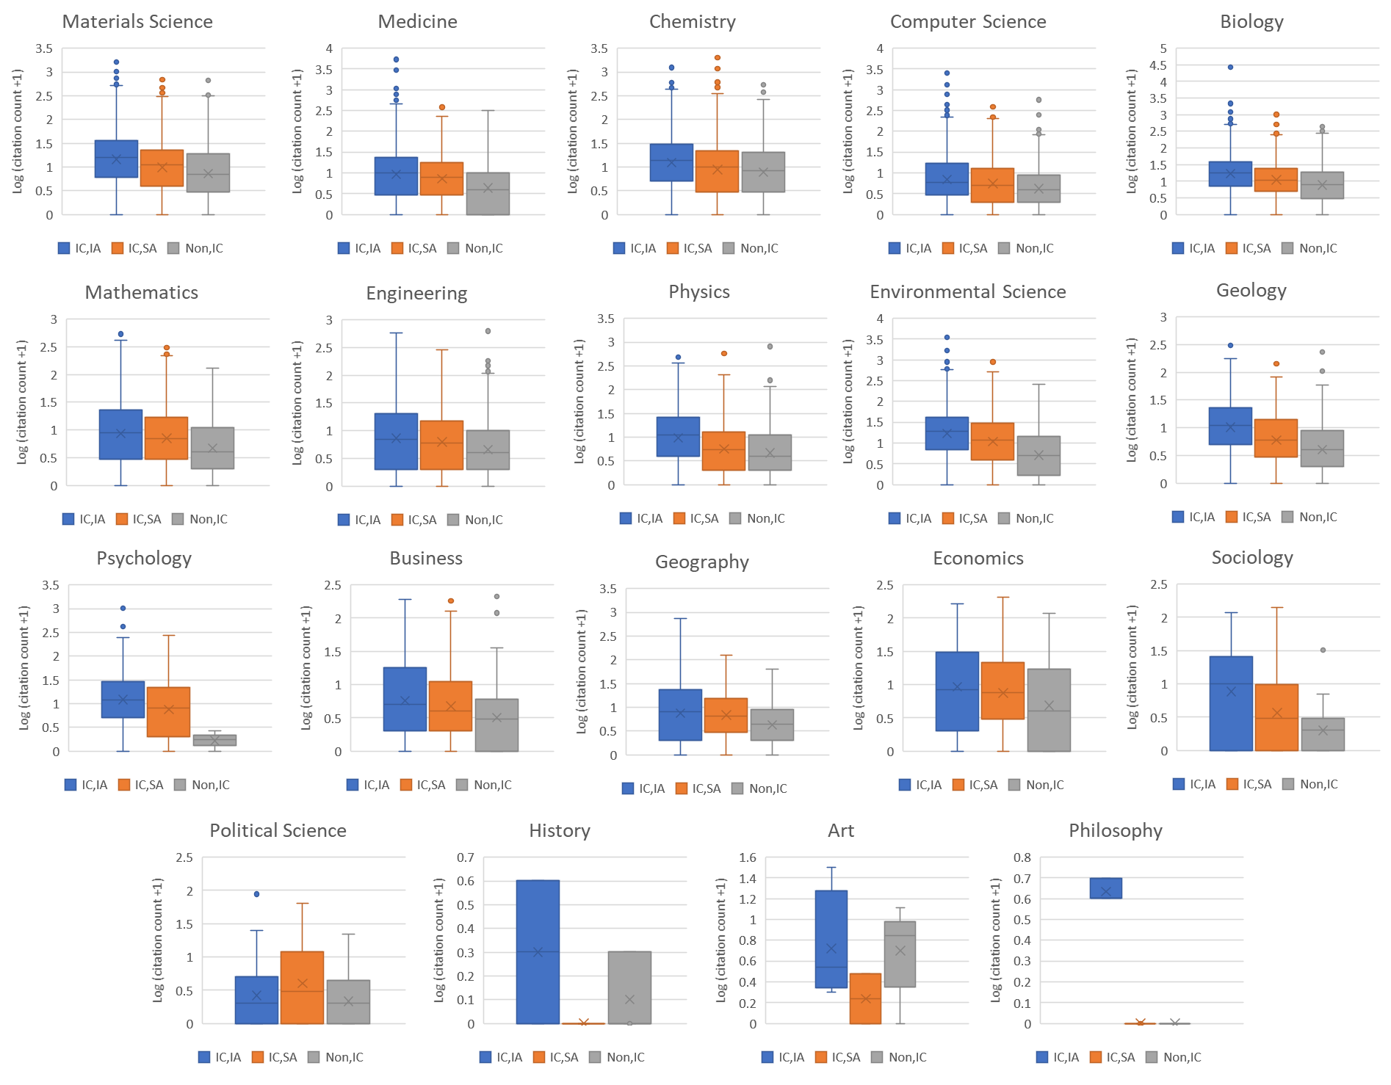
Fig. 3 Distribution of citations classified by broad area of research and first authors’ affiliation. ‘‘Dom’’ non-internationally coauthored publications; IC.SA internationally coauthored publications with «V1001» based first author’s affiliation; IC.IA internationally coauthored publications with overseas first author’s affiliation.

We would like to further elaborate five points from these primary findings:
First, our results suggest that although scientific activity in «V1001» has increased substantially over the past «V1574» years, the proportion of the world’s science coming from «V1001» is still very low. Moreover, most («V1345») of the growth in «V1001» scientific output during the past «V1574» years resulted from «V1576».
Second, our results suggest that «V1001» is still very much in the growth phase of research capacity building, which is characterized by a high level of international collaborations, but nonetheless, over this time, domestic output has increased. The high level of international collaborations is a feature indicating dependence on other countries for research capacity building. At present, the majority («V1617») of the scientific publications from «V1001» are «V1616», indicating that research collaborations have played an important role in the production of scientific knowledge production in «V1001». In this study, we distinguished between national (domestic) collaboration and international collaboration. Only «V1325» of the total output was attributable to national collaboration, whereas «V1345» was attributable to international collaboration. It should be noted that more scientifically advanced countries such as China, Taiwan, South Korea, Turkey, and Brazil had a lower rate of international collaboration ranging between 30 and 40% (Royal Society 2011; Kim 2005). Of interest, the share of internationally authored publications has slightly increased over time. In the mean time, we note that the coefficient of collaboration has «V1597» over time. These trends indicate that «V1577» was on the decline at the expense of «V1576».
We found that «V1576» was more common in experimental research fields such as life sciences and earth science, suggesting that collaboration was more likely in the form of resource sharing. Indeed, research in the life sciences and earth science requires a heavy investment in expensive technologies that are required for experimental work which could explain the high rate of international collaboration. In clinical medicine, there are also critical needs for technical skills and data collection across countries which might account for the high proportion of multiauthored publications.
Third, «V1001» has largely collaborated with more scientifically advanced countries, particularly the «V1889» and «V1890». Between «V1033» and «V1036», the number of publications with «V1592» first coauthors have increased. Increased collaboration with its former adversary, the «V1592», can be interpreted as a sign of improved science diplomacy between the two countries to address issues of common interest, including infectious diseases and the environment.
It has been assumed that scientific collaboration could improve the quality and impact of scientific research (Katz and Hicks 1997). Our results are consistent with this assumption. We found that publications with more coauthors attracted more citations. For example, the median citation of single authored publications was only «V1902», but this was increased to «V1903»for publications with 2–5 authors, and «V1904» for publications with more than 10 authors. Our finding is consistent with a previous study (Leimu and Koricheva 2005).
Forth, it is not surprising that publications with international authorship accrued more citations than publications without such collaboration. Indeed, internationally coauthored publications were more heavily cited as publications from domestic authors, and this finding is consistent with previous studies which found that publications with international coauthorship had a greater visibility compared with domestic publications (Katz and Hicks 1997; Glanzel 2001; Hara et al. 2003; Khor and Yu 2016). This is evidence that «V1001» has benefited from «V1576» research projects.
Fifth, more importantly, we note an interesting finding that the affiliation of first authors has a significant effect on the rate of citation. Internationally coauthored publications have higher citation rates, but internationally coauthored publications with the international author of correspondence accrued even more citations than those with a domestic first author. However, it is known that the authors’ affiliated country could influence the acceptability of scientific manuscripts (Baumann et al. 2011; Ceci and Peters 1982; Lou and He 2015).
However, the present findings must be interpreted within context of the strengths and limitations of the study. The major strength in this study is that we have conducted analyses on different type of publications, which allowed us to capture the full information regarding their characteristics. Our time window of «V1574» years should be adequate for a reliable estimate of the rate of growth, and adequate for documenting citation patterns (Wang 2013). The analysis of citations could be biased as the citation patterns may vary within a scientific area.
In summary, we have demonstrated that over the past «V1574» years, scientific output from «V1001» has grown at the rate of «V1182» per annum, but «V1345» of the growth was associated with international collaborations, with the «V1368» and «V1369» being the most important scientific research partners. Our analysis also indicates that international collaboration has helped increase the visibility and impact of «V1001» based research, which in turn, helped to enhance the country’s research capacity.

References

Nguyen, T. V., & Pham, L. T. (2011). Scientific output and its relationship to knowledge economy: An analysis of ASEAN countries. Scientometrics, 89, 101–117.

Archibugi, D., & Coco, A. (2004). International partnerships for knowledge in business and academia: A comparison between Europe and the USA. Technovation, 24, 517–528.

Schmoch, U., & Schubert, T. (2008). Are international co-publications an indicator for quality of scientific research? Scientometrics, 74, 361–377.

Chen, K., Yao, Q., Sun, J., He, Z. F., Yao, L., & Liu, Z. Y. (2016). International publication trends and collaboration performance of China in healthcare science and services research. Israel Journal of Health Policy Research, 5, 1.

Low, W. Y., Ng, K. H., Kabir, M. A., Koh, A. P., & Sinnasamy, J. (2014). Trend and impact of international collaboration in clinical medicine papers published in Malaysia. Scientometrics, 98, 1521–1533.

Wagner, C. S., Branmakulam, I., Jackson, B., Wong, A., & Yoda, T. (2001). Science and technology collaboration: Building capacity in developing countries (RAND, 2001). World Bank Report MR-1357.0-WB.

Nguyen, T. V., & Pham, L. T. (2011). Scientific output and its relationship to knowledge economy: An analysis of ASEAN countries. Scientometrics, 89, 101–117.

Manh, H. D. (2015). Scientific publications in Vietnam as seen from Scopus during 1996–2013. Scientometrics,
105, 83–95.

Wang, J. (2013). Citation time window choice for research impact evaluation. Scientometrics, 94, 851–872.

The Royal Society. (2011). Knowledge, networks and nations: Global scientific collaboration in the 21st century. London: The Royal Society.

Kim, M. J. (2005). Korean science and international collaboration, 1995–2000. Scientometrics, 63, 321–339. Leimu, R., & Koricheva, J. (2005). Does scientific collaboration increase the impact of ecological articles. BioScience, 55(5), 438–443.

Katz, J. S., & Hicks, D. (1997). How much is a collaboration worth? A calibrated bibliometric model. Scientometrics, 40, 541–554.
Leimu, R., & Koricheva, J. (2005). Does scientific collaboration increase the impact of ecological articles. BioScience, 55(5), 438–443.

Glanzel, W. (2001). National characteristics in international scientific co-authorship relations. Scientometrics, 51, 69–115.

Hara, N., Solomon, P., Kim, S. L., & Sonnenwald, D. H. (2003). An emerging view of scientific collaboration: Scientists’ perspectives on collaboration and factors that impact collaboration. Journal of the American Society for Information Science and Technology, 54, 952–965.
Baumann, P., Belanger, R. E., Akre, C., & Suris, J. C. (2011). Increased risks of early sexual initiators: time makes a difference. Sex Health, 8(3), 431–435.

Ceci, S. J., & Peters, D. P. (1982). Peer review–a study of reliability. Change, 14(6), 44–48. Lou, W., & He, J. (2015). Does author affiliation reputation affect uncitedness? Proceedings of the Association for Information Science and Technology, 52, 1–4.

